**MID TERM ONE ASSESSMENTS 2024**

**LEARNING AREA: MATHEMATICS**

**CLASS : PRIMARY ONE**

**PUPIL’S NAME :**

Each correct answer carries two marks.

**1.** Match correctly.

zero 5

two 10

ten 20

twenty 2

five 0



**2.** Draw these sets.

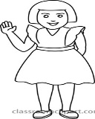A set of two girls

A set of three books



A set of five pencils



A set of four boys

**3.** Add these numbers.

5 + 5 = 10 8 + 1 = ___________

**4.** Fill in the missing numbers.

10 , _____ , 12 , ______ , 14

1, _____ , _______ , 4 , 5 , ______.

**5.** Draw these shapes.

|  |  |  |  |  |
| --- | --- | --- | --- | --- |
|  |  |  |  |  |
| star | circle | kite | triangle | rectangle |

**6.** Circle the number between;

8 9 10 40 50 60

15 20 25 1 2 3

**b)** Underline the number before.

**50**  51 18 19

33 34



**7.** Count and write the number.

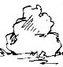

 = **3**



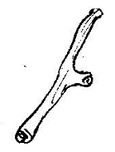

= ______ = _______



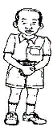

 = _____ = _______

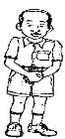







 = _________

**8a).** How many days make a week? ( 7 , 5 )

__________________________________________________________

**b)** Fill in the missing letter.

M ___ nday Fr ___ day

Wed ___ esday Sun ___ ay

**9a)** Arrange these numbers starting from the smallest to the biggest.

50 , 40 , 30 , 20 , 10 , 00

00 , 10 , 20 , 30 , 40 , 50

5 , 4 , 3 , 2 , 1

___________________________________________

15 , 14 , 13 , 12 , 11

_________________________________________

**b)** Write these numbers in words.

5 = _______________ (twenty, five , one)

20 = _______________

1 = _______________

**10.** Compare using “taller” and “shorter”.

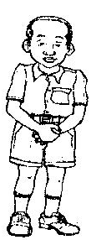 Tom

 Joy

Tom is _______________ than Joy.

Joy is ________________ than Tom.

**b)** Subtract correctly.

10 – 6 = 4 9 – 3 = ________

2 - 1 = ________ 15 - 5 = ________

**11.** Number of eggs that four children have.

|  |  |  |  |
| --- | --- | --- | --- |
|  |  |  |  |
| Mary | Peter | Sarah | Jane |

**Questions.**

Fill in the gaps correctly.

**a)** Mary has _______________ eggs.

**b)** ___________ and _____________ have the same number of eggs.

**c)** ___________ has more eggs.

**d)** ___________ has less eggs.